
Badminton Summer Camp
Terenure & Baldoyle
1 Week - €125
2 Weeks - €220
Subsequent Family Members - €90 per week
5 Day Badminton Summer Camps
July and August 2017
Monday to Friday
For ages 6-17 years of all abilities

- Participants will learn key badminton skills and techniques with coach Mark Topping
- Camps will use a combination of group activities, drills and games to encourage learning
- All Camp Leaders are fully qualified Badminton Ireland coaches with years of experience
- Individually focussed technique improvements
- Mini-tournaments and competitions to improve team-playing skills
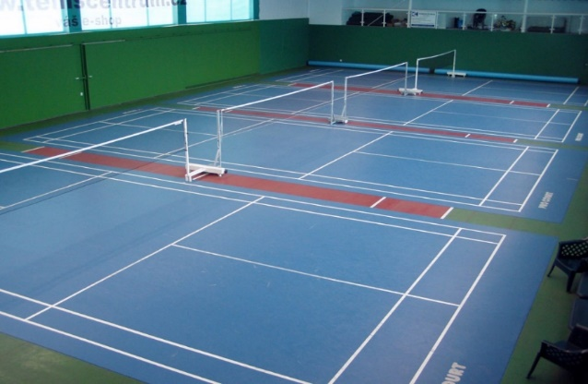
Classes run from 10am to 2pm each day (See dates on Application form)
Lunch break at 12pm
Please bring a packed lunch and water

For any queries please call
Mark Topping
087-6131432

Cheques to be made payable to Mark Topping and posted with a completed copy of the attached application form to:
23 Prospect Heights, Prospect Manor, Rathfarnham, Dublin 16
Application forms must be received at least two weeks before the camp starts.
